CS3S663 – Implementation and Testing of a Mobile App

Assessment 2

Connor Moloney - (30019559)

2024

Table of Contents

Introduction 2

Objectives 2

Implementation 2

Code snippets 3

Challenges faced 8

Testing 9

Conclusion 10

References 10

## Introduction

This report documents the development and testing of a SwiftUI application tailored for iOS devices, with the primary function of tracking work-related expenses. The application serves as a practical tool for users to monitor the progress of their expenses and manage reimbursements efficiently. Also providing the ability to store receipt photos, helping enhance the comprehensiveness of expense documentation. Utilising the SwiftUI framework, the application is designed to offer an intuitive user experience, leveraging the capabilities of iOS devices to provide seamless navigation and expected functionality. The focus of this report will be to provide an in-depth overview of the development process, problems encountered, and testing undertaken to ensure the reliability and robustness of the application.

## Objectives

* Develop a SwiftUI application tailored for iOS devices
* Implement features to enable tracking of work-related expenses
* Provide functionality for users to monitor the progress of expenses and payments
* Enable users to store photos of receipts within the application for comprehensive documentation
* Ensure a user-friendly interface and smooth navigation through the application
* Conduct thorough testing to validate the reliability and robustness of the application

## Implementation

Throughout the implementation of this project, a structured approach was followed, consisting of four distinct phases aimed at progressively enhancing the applications functionality and reliability. These phases are outlined as follows:

### Core functionality implementation

Initially, the focus was on establishing the foundational elements of the application. This involved conceptualising required views and implementing core functionality, such as recording expense summaries and total amounts. By starting with a simplified version utilising only two variables, it enabled me to ensure the basic functionality was working as expected and work out any bugs presented much more efficiently.

### 2. Feature enhancement

Following the successful implementation of core functionality, efforts were directed towards enhancing the application by incorporating additional features. This included the introduction of functionalities such as VAT options, including dates, receipt photo integration and the ability to mark expenses as paid. These enhancements aimed to broaden the scope of the application and improve its utility for users.

### 3. Feature refinement and additions

Subsequent to the addition of new features, the focus now shifted towards refining and optimising the existing functionalities along with adding some additional useful functionality. This phase involved the implementation of enhancements such as filtering expenses by paid status, sorting by incurred date, introducing a full-screen receipt photo view and utilising ternary conditional operators to update text in views under certain conditions. Efforts were also made to enhance the codebase by performing small-scale refactoring to improve readability and reduce code duplication, this was partially achieved. Given more time the data entry for the ExpenseAddView and ExpenseEditView would become its own view, called to required views to stop the duplication of code in these files. These elements have been achieved within my code however I didn’t have time to test them thoroughly before submitting so it was better left out to ensure my program does exactly as tasked.

### 4. Testing and debugging

The final phase of the implementation centred on thorough testing and debugging to ensure the stability and reliability of the application. This involved conducting various testing procedures to identify and rectify any bugs or inconsistencies encountered during the development process.

By adhering to these structured phases, the implementation of the project progressed methodically, enabling the gradual enhancement and refinement of the application’s functionality. This approach facilitated efficient development while ensuring a high quality and reliable final product.

## Code discussion

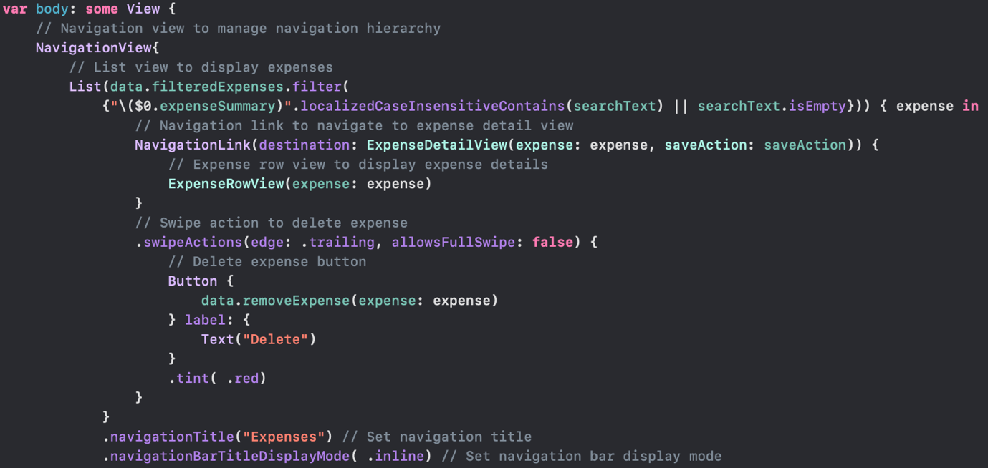

The code above shows the RootView body, this is the entry point for the program and shows the code for listing expenses. A navigation view is used to enable linking to the expense detail view, a list is placed inside the navigation view which loops through the returned filtered expenses filter creating links using the expense row view to display a brief summary of the expense. A swipe action is added to the expense row view to give users the option to delete expenses.

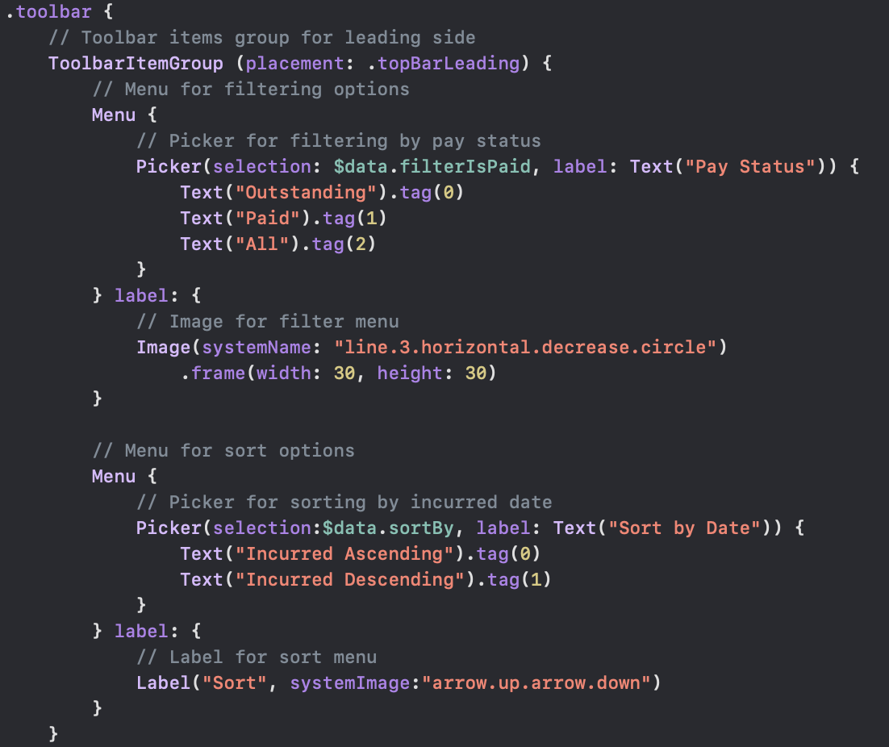

The code above shows the toolbar options for the RootView which includes a filter by paid option and sort by incurred date. The picker uses a binding to filter is paid which is a computed property in Expenses, which returns a subset of the expenses list based on which selection is made, the code is shown below for this feature.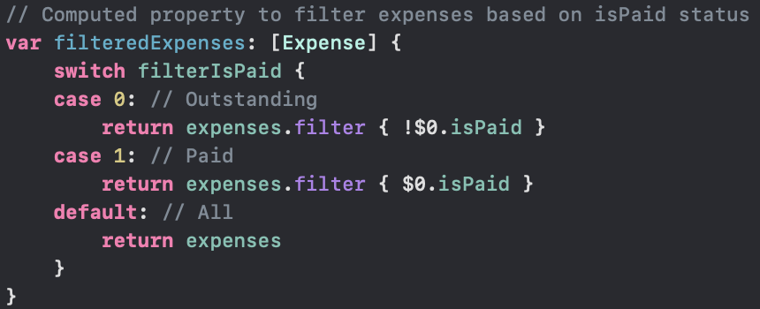

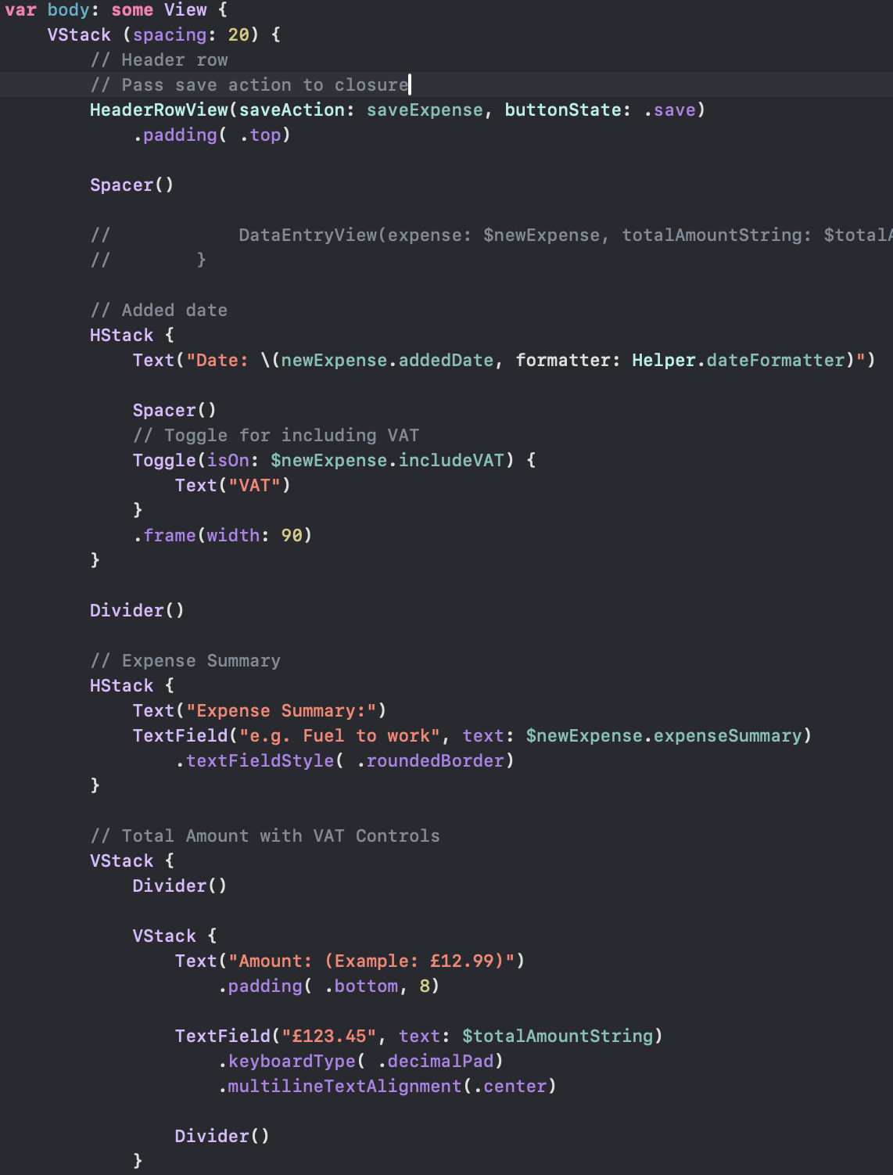

On the root view there is also the ability to add expenses, a circle plus icon on the toolbar takes you to the expense add view shown above. In this view there was a lot of duplicated code with the expense edit view and also the detail view, to solve this problem in all scenarios possible I refactored the duplicated code into its own view and called an instance of it where necessary. This makes the code base more readable and reduces the amount of code which can improve app performance and makes maintenance harder as you have to update the same code in multiple places which can lead to inconsistencies throughout the app if one is forgotten. One of the places I achieved this was with the header row view, where each has two buttons and a spacer. All of the headers had a cancel button and then an action button with Save, Edit or Update as the text with the respective action. Using the code below this was updated to require just calling an instance of header row view and passing a button state and a closure action to it.

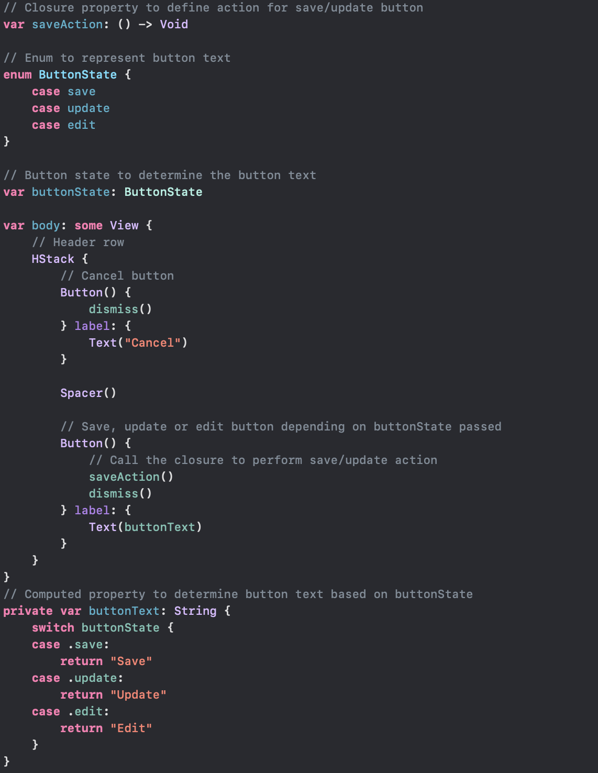

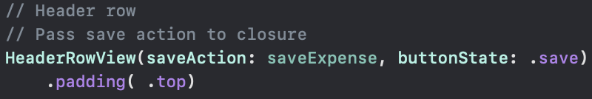

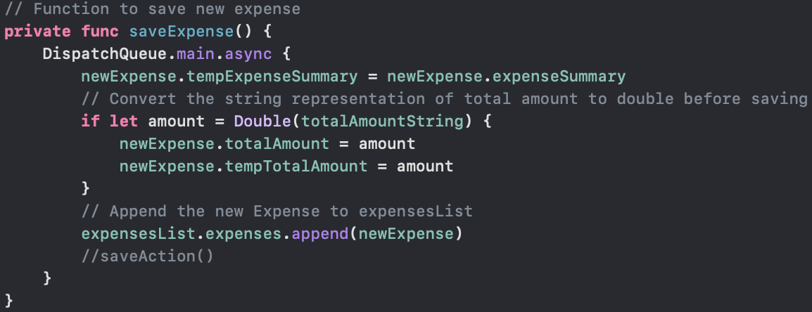

As you can see this is a more efficient solution compared to having three header row declarations just to change the action of one button. I wanted to put this into practice for the data entry/viewing to stop the duplication of about eighty lines in three views, however I unfortunately ran out of time and couldn’t solve the issues with how I had set up my data structure allowing me to create a binding in a child view to pass to another child view. The code has been left in my files for your viewing to show the thought process behind the refactoring albeit commented out.

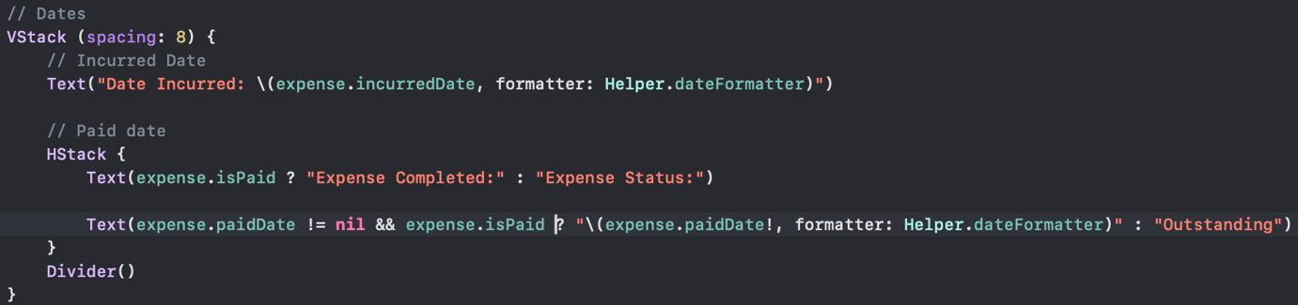

This code above is responsible for marking orders as paid or completed, it uses a ternary conditional operator to decide what shows in the view. This is a clever way to minimise the code needed for a simple dynamic switch of text. The second text uses a double check to guard against paid date being nil and is paid being true to update the text to show the date the expense was marked as paid. My thought process behind this was in a real-world scenario this app would likely be linked between employees and employers so the employers would mark it as paid after the payment was handled giving it the current date.

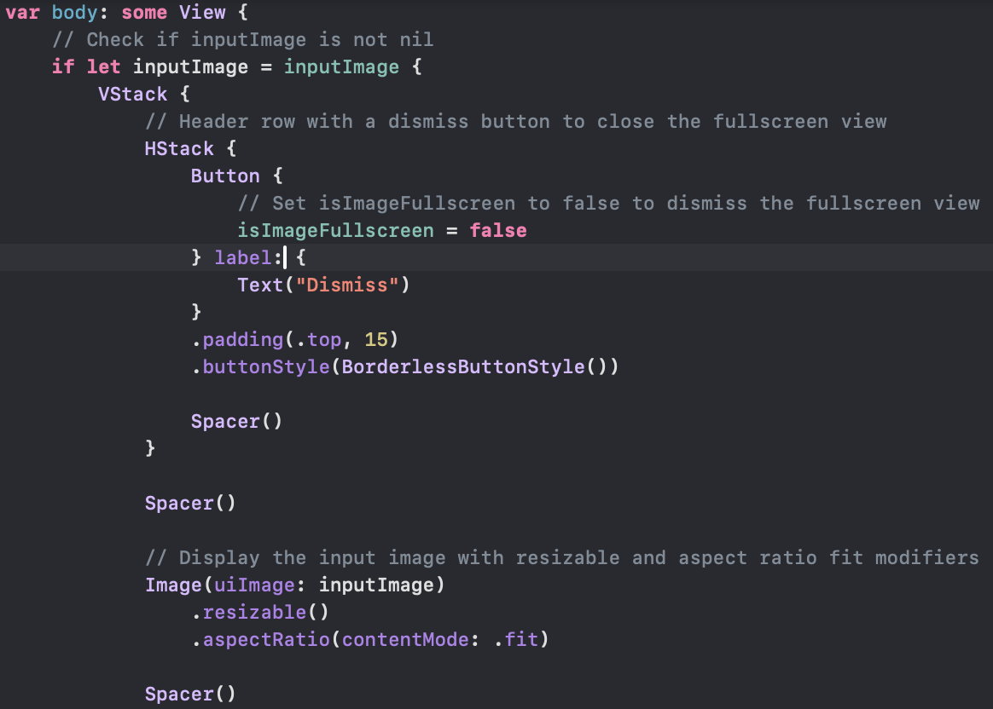

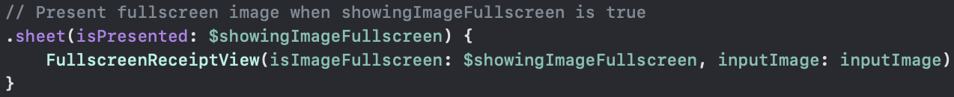

Another design choice I made was including a full-screen photo view to enable a preview of images when they were tapped, I thought this was a handy addition to the program making it easier to identify a receipt photo. The code for this can be seen above, it follows the same loading structure as the other sheets used throughout the program.

## Challenges faced

During the course of this project, numerous setbacks were encountered, albeit successfully overcome, with the exception of the refactoring of the data entry into its own view. Challenges arose primarily from issues related to data-structure configuration and the utilisation of a binding of type Expense created with an observed object type in the parent view, intended for sharing data between two child views. A potential workaround would have involved defining the new expense binding in the parent view. However, due to time constraints, thorough testing of this approach could not be conducted. Consequently, efforts were redirected towards ensuring the functionality of the remaining components of the program and conducting extensive testing on other elements.

Another notable challenge emerged during the implementation of the marking expenses as paid feature. A custom checkbox view was developed to enhance user experience, as opposed to employing a toggle switch commonly associated with settings. This custom view toggles a variable bound to the isPaid status, visually representing it with a transition from a red checkbox square to a green ticked checkbox square. However, attempts to persistently store the updated expense by changing the app's phase resulted in the value reverting to its previous state upon reload. Resolution of this issue necessitated direct toggling of the isPaid value, bypassing reliance on automatic changes through binding. Additionally, difficulties were encountered in ensuring accurate date updating, initially resulting in the initialisation of the date value to the same date as that of the expense creation. Addressing this issue involved implementing an onChange modifier to monitor changes in the isPaid variable and updating the paid date accordingly, instead of relying solely on the on-tap gesture. Furthermore, the paid date variable was initialised to nil rather than a specific date value, resolving discrepancies in date initialisation.

Another challenge encountered during the project pertains to the apparent delay in data writing to the device upon scene phase changes. Observations revealed a delay of approximately five to ten seconds before the app could be closed properly, ensuring data persistence. This issue could potentially be mitigated by employing background threads responsible for saving data to device storage, thereby allowing threads to handle saving processes even after the app is closed, ensuring completion. However, due to constraints in both time and expertise regarding threading within Swift, no attempt was made to implement this solution.

Additional challenges arose in determining the implementation of certain features, such as saving to the device upon button clicks, such as "save" and "update". While such a feature may seem logical in theory, it could be considered poor practice in an industry setting, particularly if the application were to utilise online data storage, where frequent reads and writes could increase latency and costs, potentially leading to issues if users were to repeatedly interact with buttons. While such concerns are less pertinent in our application, as data is saved locally, the inclusion of this feature could introduce delays and decrease performance, prompting its exclusion.

Another feature deemed unnecessary is the automatic saving upon scenePhase change within the edit view. Implementing this feature would save temporary changes before they are confirmed, which is undesirable. Similarly, the inclusion of a camera option within the image picker was dismissed as it would entail investing development time into a feature that cannot be tested or proven due to limitations of the simulator.

Regrettably, time constraints precluded the implementation of input checks within the application. However, this is not perceived as a significant issue, as the date picker restricts input to valid dates, the total amount field employs the decimalPad keyboard type to prevent non-numeric characters, and the expense summary variable utilises a string, accommodating any characters entered via the keyboard. Despite these considerations, the assumption that users will input all required values into the program has been made. Nonetheless, this could be addressed in future iterations of the application.

## Testing

Testing was given extensive thought and covers all features of the program, below lists all of the tests that were completed in testing of the application.

### Listing all expenses

In the image above you can see all of the expenses listed using the expense row view.

### Add new expense

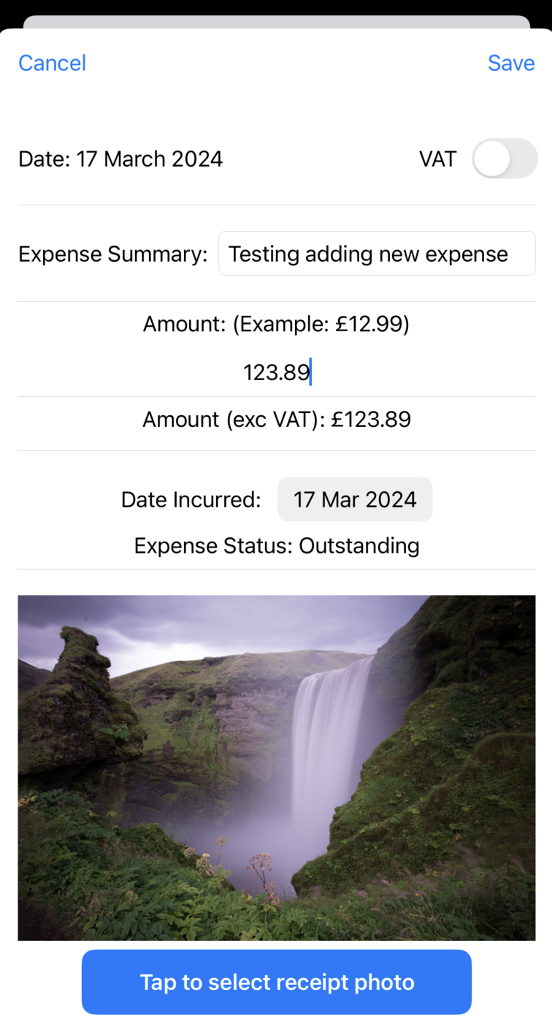

Image above shows the creation of a new expense.

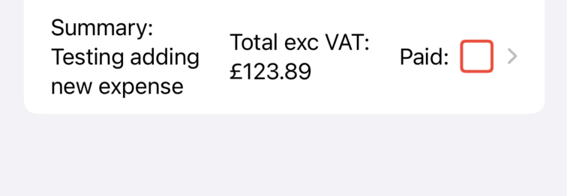

Image above shows the new expense listed in the root view after it has been created.

### Delete expense

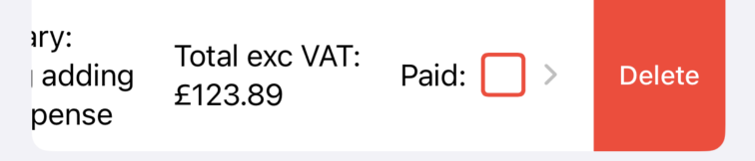

Image above shows the delete swipe gesture being shown.

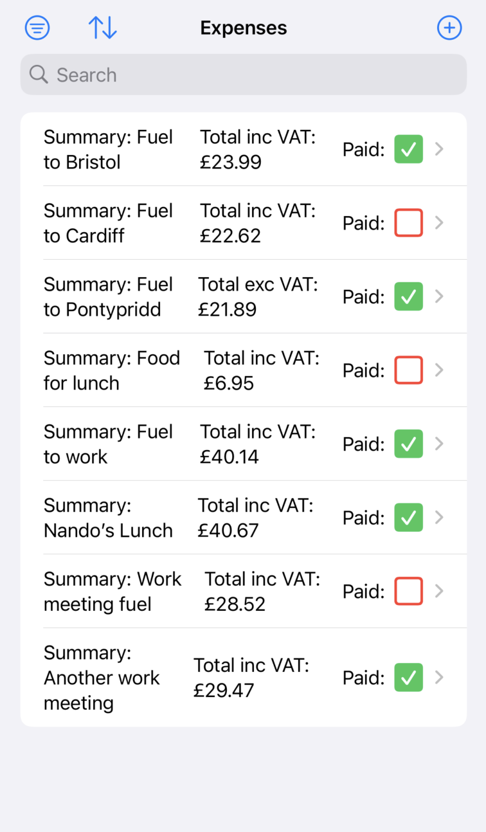

Image above shows the expense no longer in the expenses list.

### Sort by date

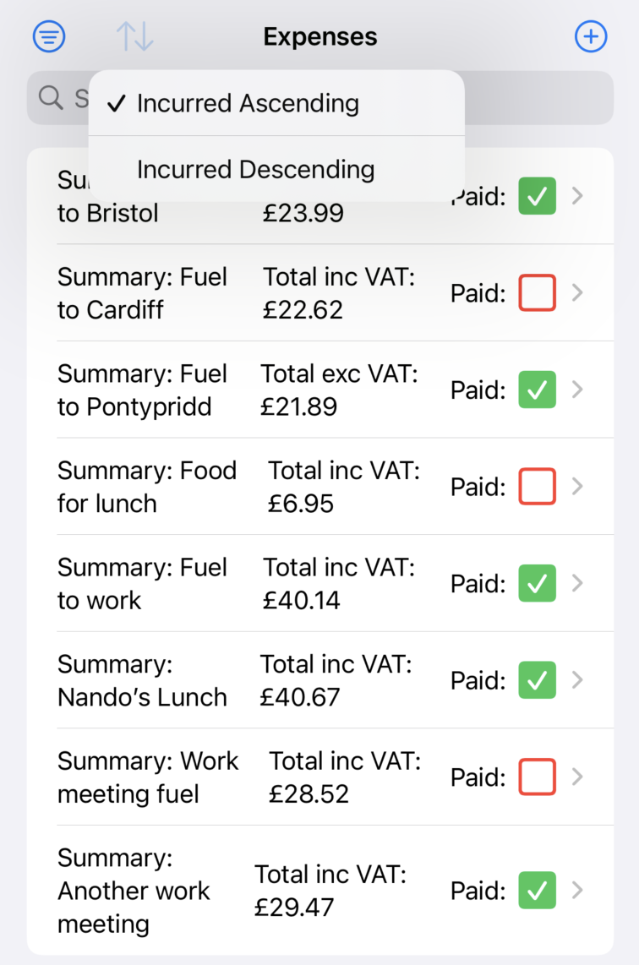

Image above shows the sorting options for incurred date ascending or descending.

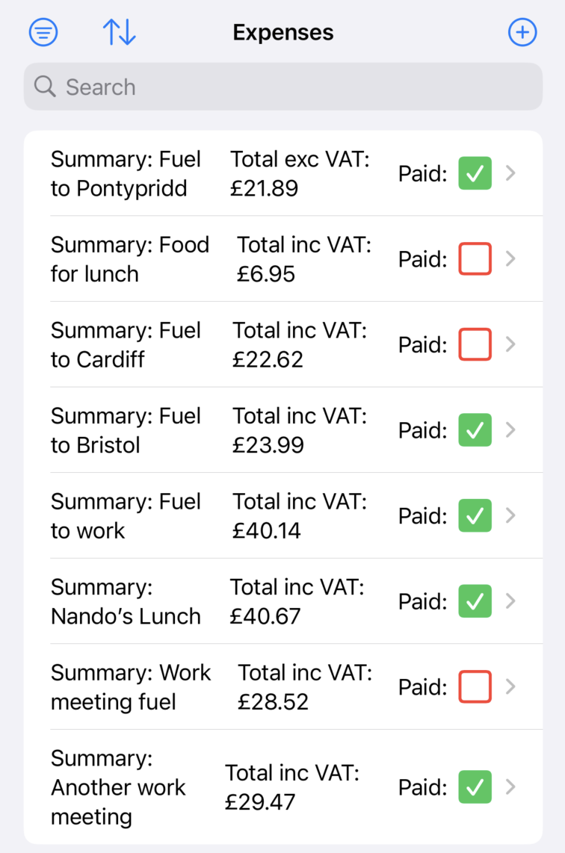

Image above shows the sorted expenses list.

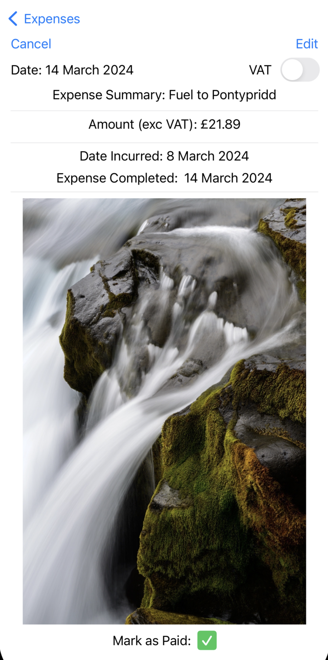

Image above shows the incurred date as 8th March 2024 for the first expense in the list,

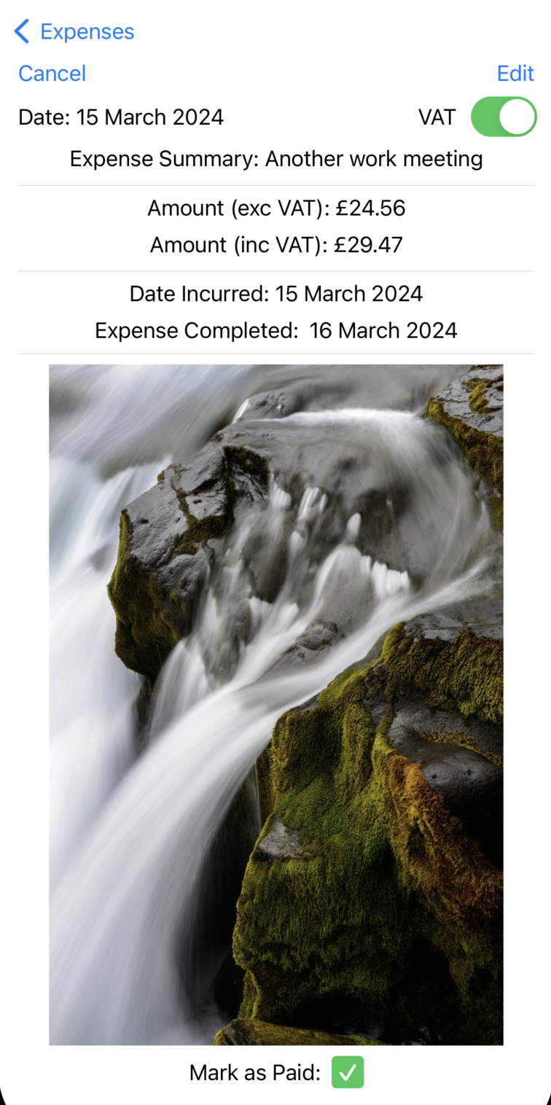

Image above shows the incurred date as 15th March 2024 as the last expense.

Image above shows selected sort mode as descending.

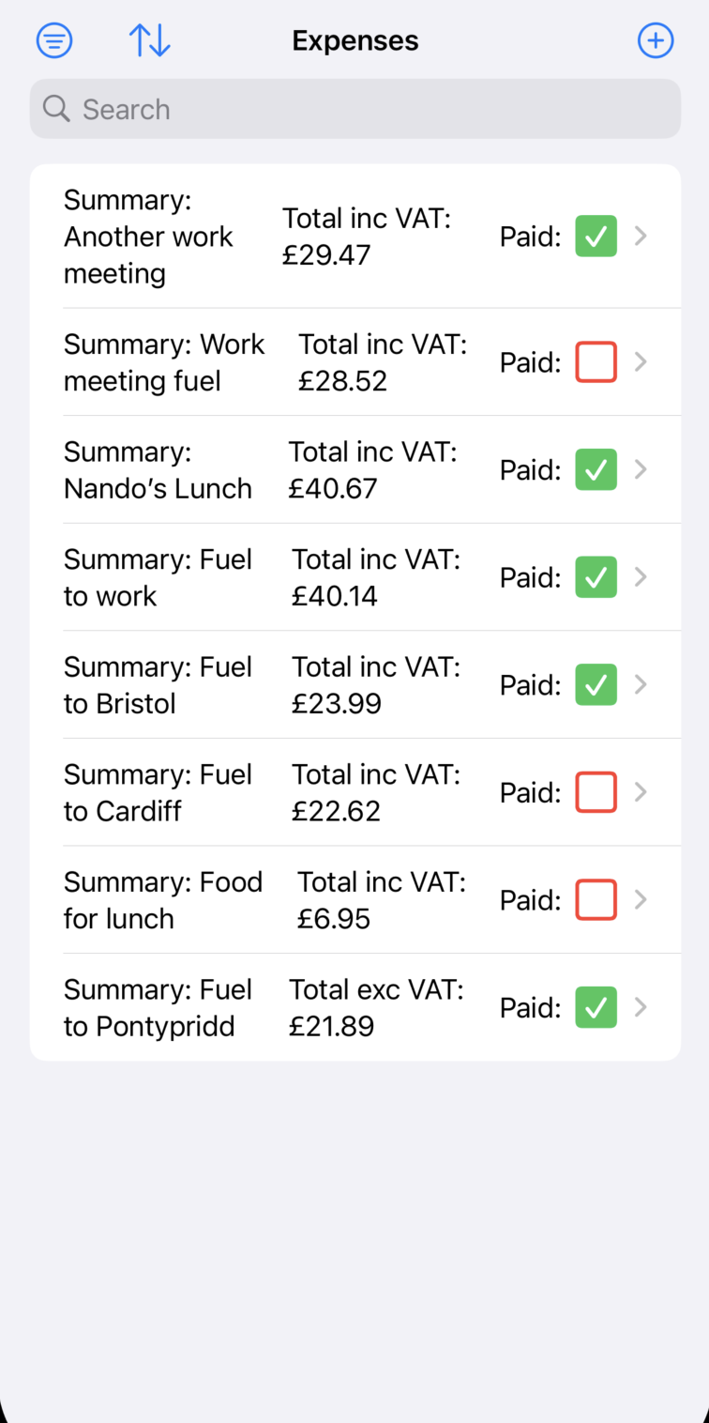

Image above shows the expenses list in opposite order to previous sorting picture.

### Filter by isPaid

Image above shows the is paid filter menu.

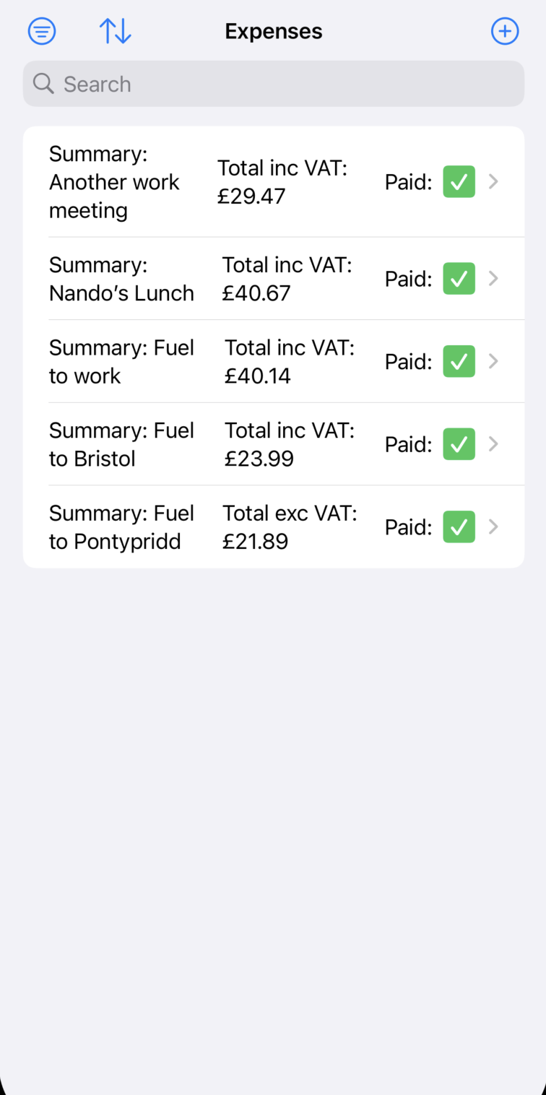

Image above shows the expenses filtered by marked as paid.

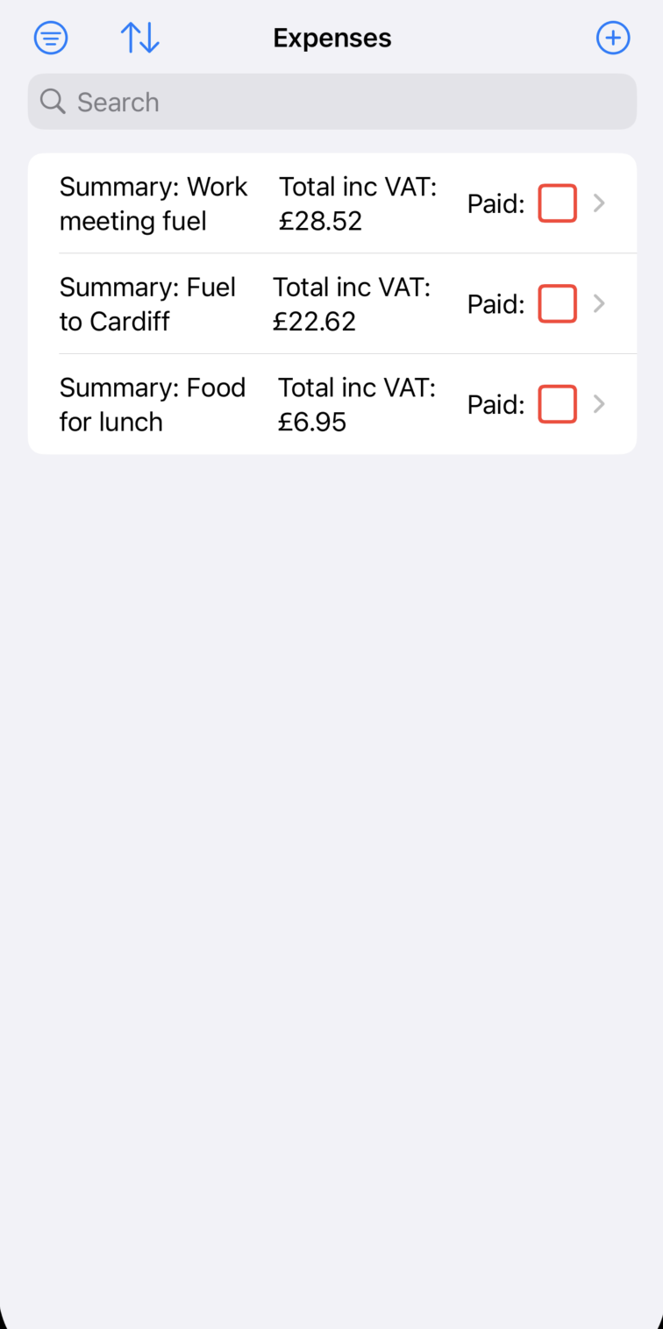

Image above shows the expenses filtered by marked as unpaid.

### Search by summary

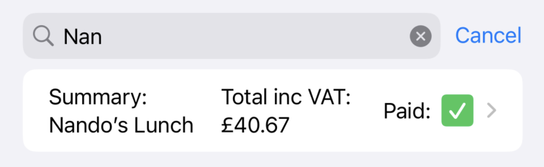

Image above shows a search result for “Nan”.

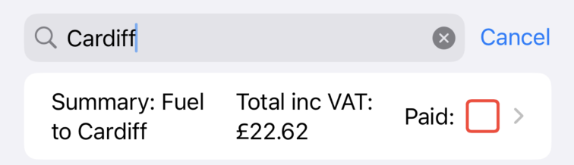

Image above shows a search result for “Cardiff”.

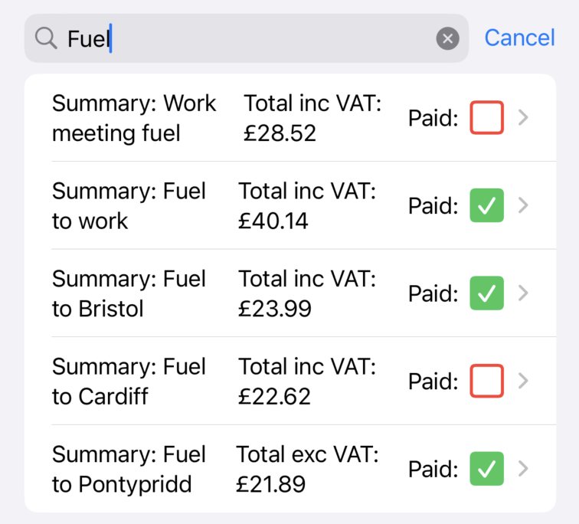

Image above shows a search result for “Fuel”.

### Fullscreen photo



Image above shows the full-screen photo view.

### Detail view



Image above shows the expense detail view working.

### Edit view

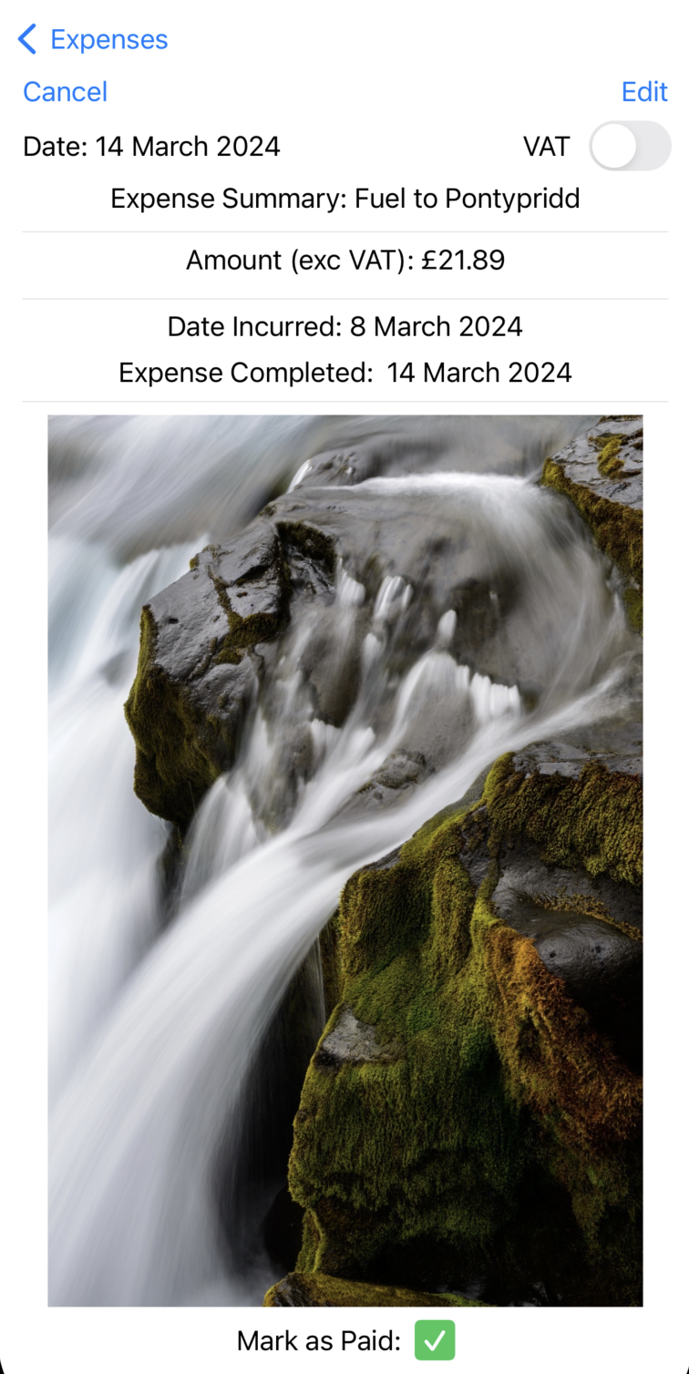

Image above shows the expense detail view before edit has taken place.

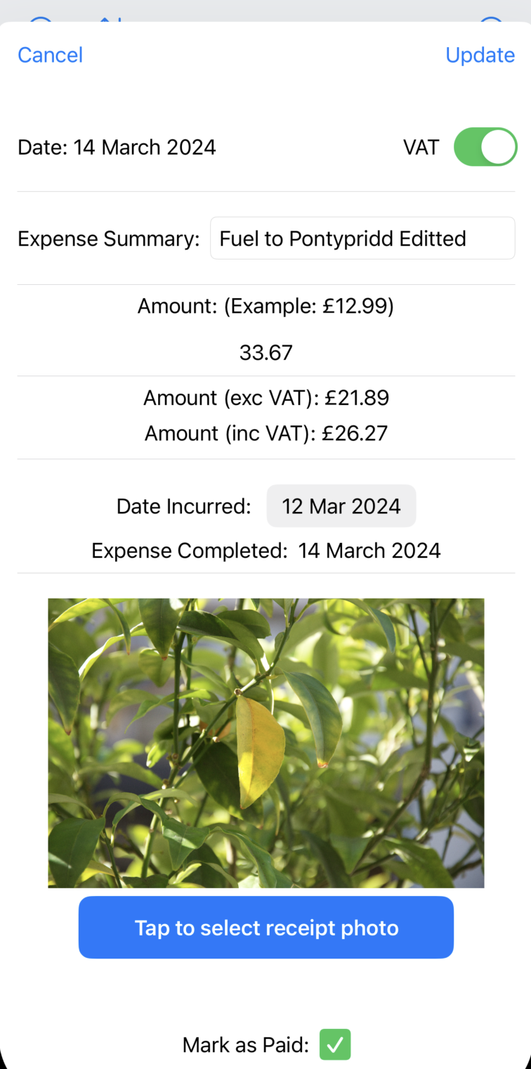

Image above shows the expense edit view after changes have been made but before it saves.

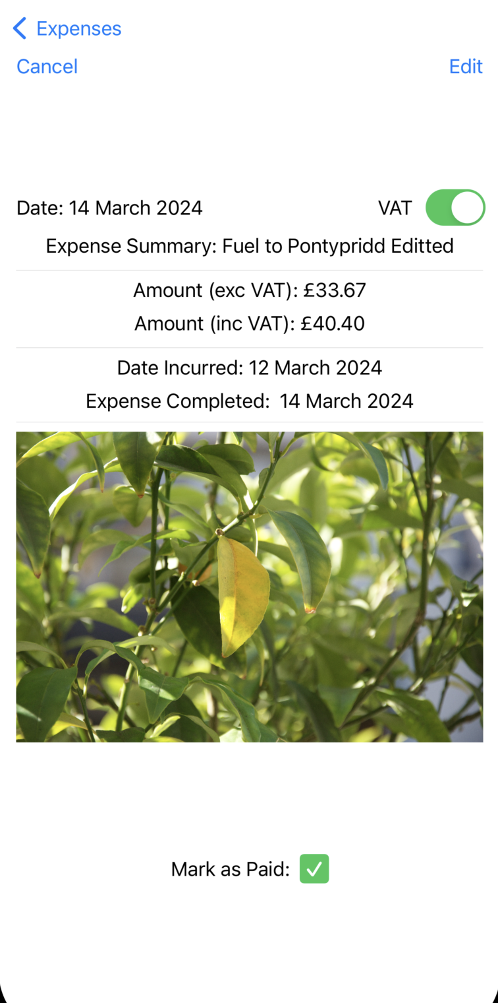

Image above shows expense detail view after the changes have been added.

### Mark as paid

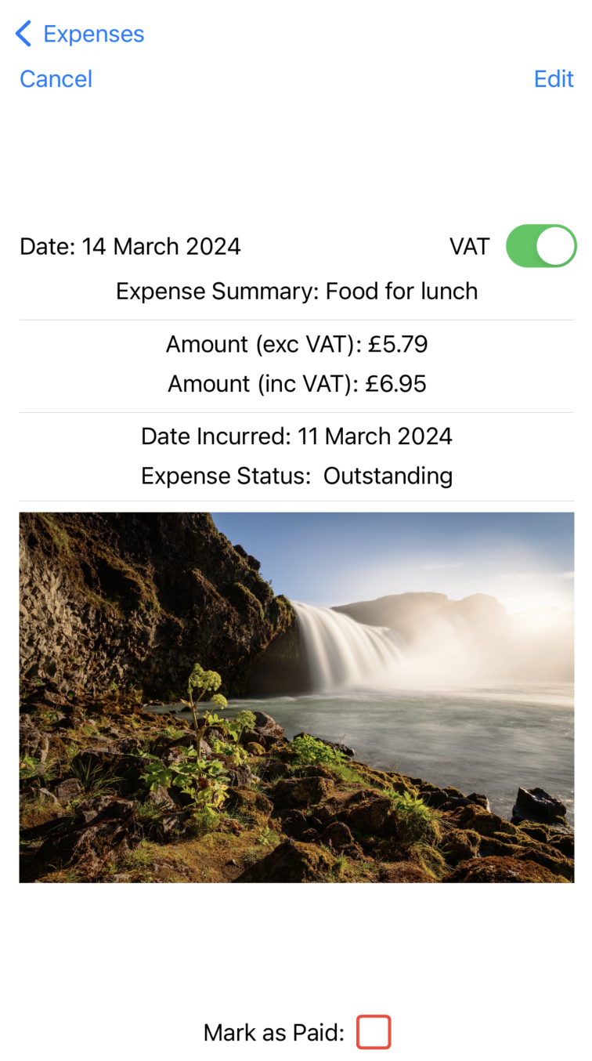

Image above shows an expense marked as unpaid.

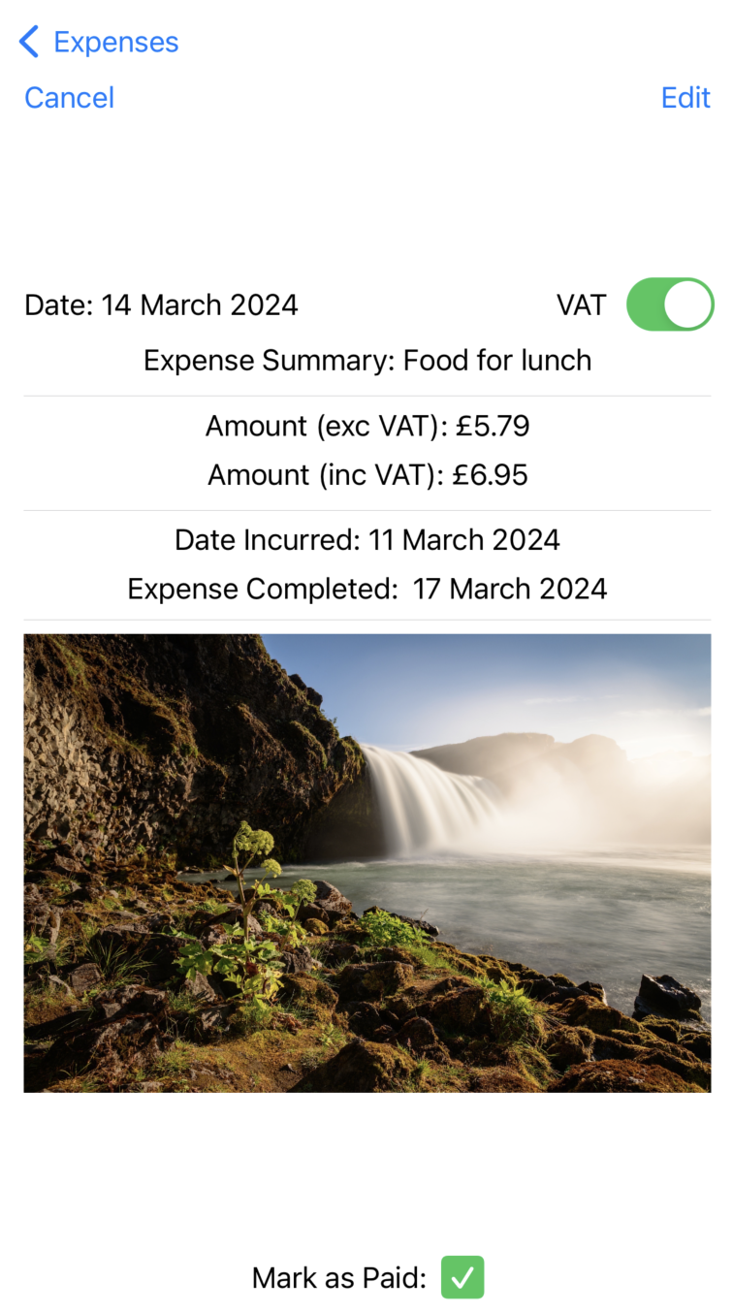

Image above shows the same expense after it has been marked as paid.

### Persistent storage

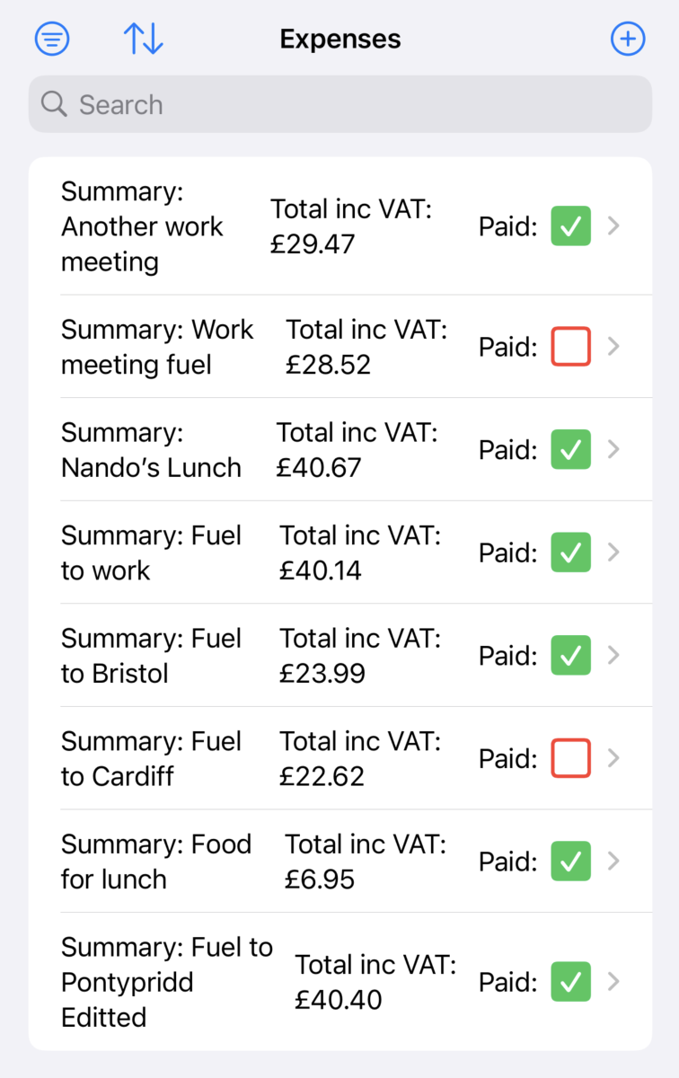

Image above shows the expenses list with the edited expense at the bottom which hasn’t been made persistent yet.

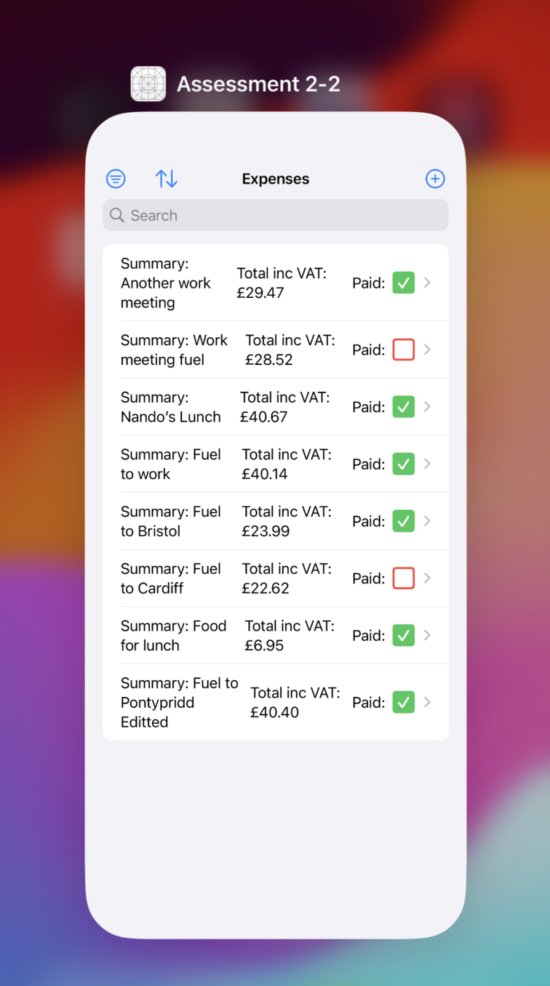

Image above shows the app being sent to the background.

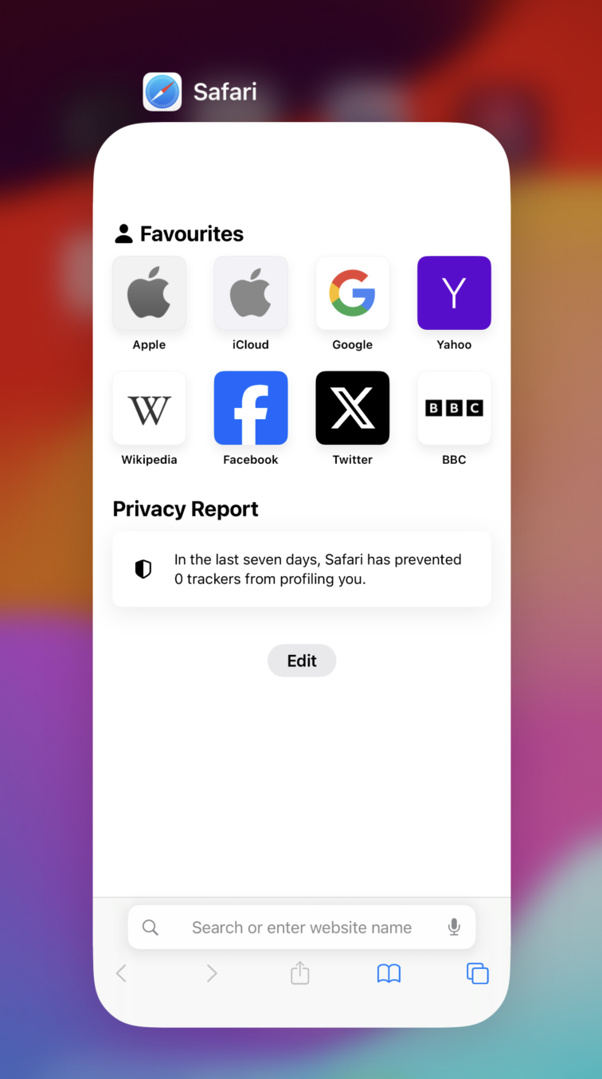

Image above shows the current open applications, so no expenses app open.

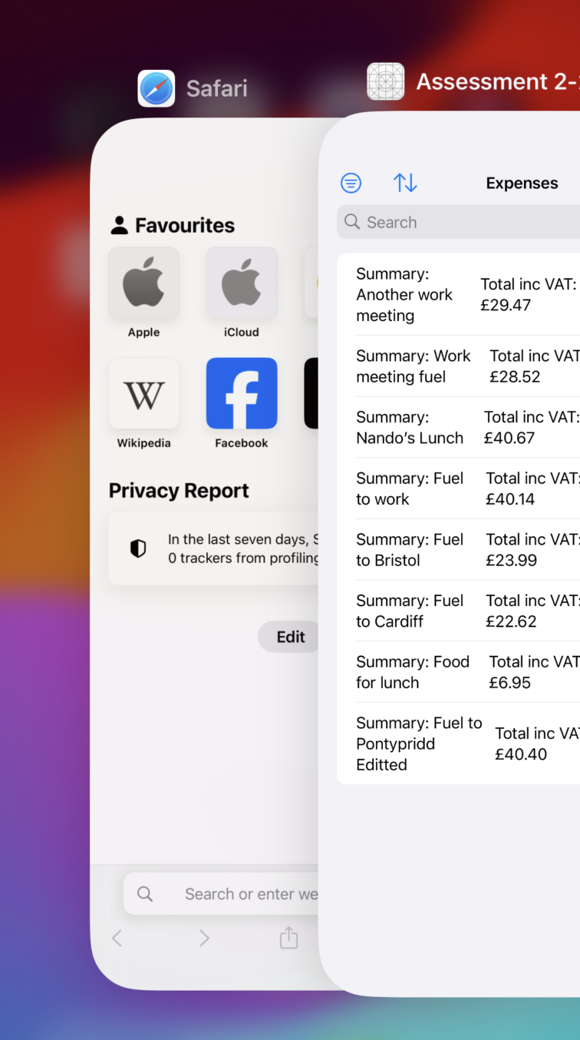

Image above shows the expenses app opened again.



Image above shows the expenses list after it has been made persistent.

## Conclusion

In conclusion, the development and testing of the SwiftUI application aimed at tracking work-related expenses have been meticulously documented in this report. The project's objectives, ranging from developing a user-friendly interface to conducting thorough testing, have been successfully achieved. Through structured implementation phases, core functionality was established, followed by feature enhancements and additions, ending with robust testing and debugging procedures to ensure stability and reliability.

Despite encountering challenges, such as difficulties in data-structure configuration and persistently storing updated expenses, effective solutions were devised. Moreover, strategic decisions were made regarding feature implementations, such as excluding automatic saving upon scene phase changes from certain views and camera integration, to maintain focus on essential functionalities and mitigate potential performance issues.

Testing procedures were comprehensive, covering all aspects of the application, from expense listing to editing, sorting, filtering, and persistent storage validation. Each test scenario was meticulously executed, ensuring the application's reliability and robustness across various user interactions and system states.

While certain challenges remain unaddressed, such as the implementation of input checks and further refactoring for code efficiency, these considerations would have been made for future improvements given more time.

In essence, this project demonstrates a structured and iterative approach to software development, where challenges are met with innovative solutions, and testing ensures the delivery of a high-quality, reliable product. Through the documentation provided, insights into the development process, challenges faced, and testing methodologies employed offer valuable lessons for future endeavours in software development and project management.

## Useful Links used in project

Assistance with formatting a text field for numbers. <https://www.hackingwithswift.com/quick-start/swiftui/how-to-format-a-textfield-for-numbers>

Code used for the image picker view.

<https://www.hackingwithswift.com/books/ios-swiftui/importing-an-image-into-swiftui-using-phpickerviewcontroller>

Knowledge and understanding of Swift language.

<https://codewithchris.com/>